Krifka, M. 1990 “Four Thousand Ships Passed Through the Lock: Object-Induced Measure Functions on Events.” Linguistics and Philosophy 13:487-520.
Monday February 26, 2007. Semantics II

Krifka introduces a null determiner which takes the measure of the object and extends it to the events.

The Basic Data:
(1) a. Four thousand ships passed through the lock last year.
b. The library lent out 23,000 books in 1987.
c. Sixty tons of radioactive waste were transported through the lock last year.
d. The dry cleaners cleaned 5.7 million bags of clothing in 1987.
e. 12,000 persons walked through the turnstile yesterday.
- Object-Related Reading: There were 4000 ships, there must be 4000 distinct ships
- Event-Related Reading: There were 4000 ship-passings, there can be less than 4000 distinct ships
Outline of the paper:
Section 2 : Krifka’s 1986 Framework (as much as is needed)
Section 3 : Two versions of this analysis
Semantically simple, strange syntactic constituents
Semantically complicated, syntactically normal
Section 4: Problem cases
Coordination
Quantifiers
Comparison
Anaphora
Phase nouns
Section 5: general extension of measure functions from one domain to another.
1.2. Two Possible Analyses - And Why They Fail
Event-related reading is in the meaning of the noun:
- Gupta 1980
- The identity criteria of passenger and person are different.
- Common nouns don’t apply to individuals but to individual concepts,
- Thus: Passenger 1 and passenger 2 might be two non-identical individual concepts that have the same value at some point, ie Mary.
(2) a. National Airlines served at least two million passengers in 1975.
b. Every passenger is a person.
Object-Related continuation:
c. #National Airlines served at least two million persons in
1975.
- Carlson 1982
- Person applies to objects, batters applies to stages of objects
Krifka agues against locating the meaning in the noun:
- There are words like “ship” that allow both readings
  - Would need two lexical entries for “ship,”
    - ship objects,
    - stages of ship objects
- Problems with counting ship stages:
  - Say Ship Eleonore has two stages: s1,s2
  - By our counting mechanism, this makes three stages (s1,s2,s1&s2)
  - Hard to count mass nouns like radioactive waste, esp if they pass on different ships
1.3. A New Solution
- Krifka’s 1986 Framework
- Accounts for:
  - Mass nouns
  - Count nouns
  - Measure constructions
  - Temporal constructions
- Ingredients:
- Link’s algebraic (lattice theoretic) semantic approach to Mass & Plural nouns
- Davidsonian event semantics
- Theory of measurement
2.1 Lattice Sorts
From Landman 1991 “Structures for Semantics” p255
- Link (1983) says that if you add a sum operator to the domain of individuals (a,b), you can get plural noun phrases(a & b). This is essentially the structure of a complete atomic join semilattice.
- The “sum” operation is called the “join” or “ʌ” operator in lattice theory, the “⊕” operator in Link, and the “∪” operator in Krifka.
- Need to add some more constraints so that the lattice makes sense, we want our lattices to be completely generated by an unordered set so we don’t need the null set,
- Normal lattices have both the join (&) and meet (or) operations. For plurality we just need the join (&) operator.

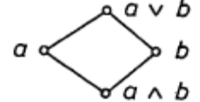
a b c
d
f
Sort Σ
Domain E
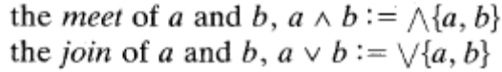
Infimum of X is “ʌX” Supremum of X is “∨X”
- So plurality is represented as a <A, ʌ> semilattice.
Σ :
a∪_{Σ} b∪_{Σ} c
a ∪_{Σ} b
a ∪_{Σ} c
b ∪_{Σ} c
a
b
c

- Krifka adds a number of functions and derives some theorems which we will look at as they are needed in the analysis.
X’’
X
X’ d
- Some key definitions:
  - Communicative : order of elements is immaterial
  - Idempotent : yields the same result whether it is done only once or several times
  - Associative : order of evaluation is immaterial
- Σ is a sort which has an internal structure of a lattice
- b ∪_{Σ} c is a plural individual
- Supremum sup_{Σ} = a∪_{Σ} b∪_{Σ} c
f
y
x
- x and y overlap x ⋄_{Σ} y = f
- Proper part x’ ⊂_{Σ} x
- Witness element =d
- Partition= whenever x is part of the join of y and z, then x is part of y or of z or a bit of both.
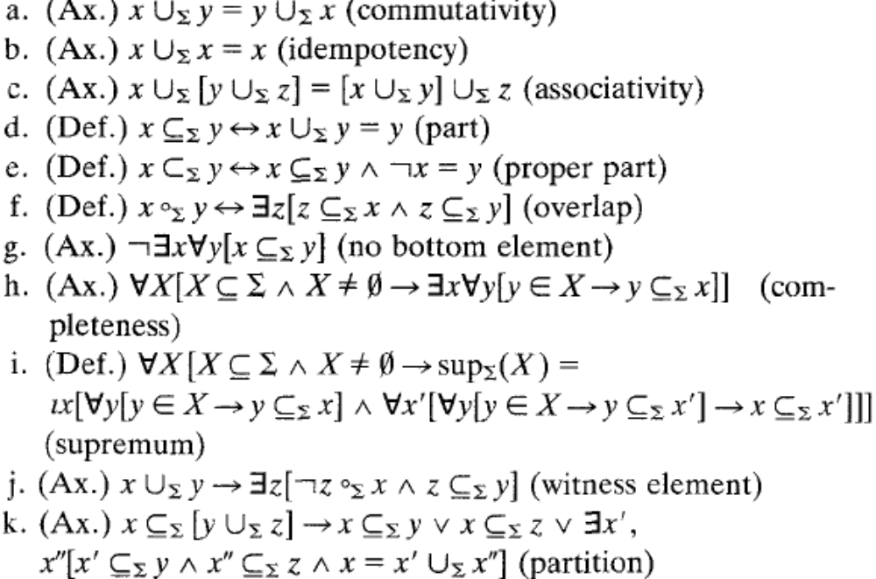
- Krifka shows that the structure derived is a Boolean algebra with the bottom element removed. He goes through a number of axioms which apply to this.
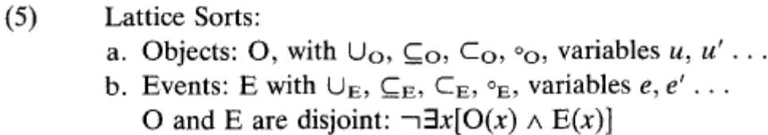
- Using Lattice Sorts we can specify the cumulative reference property of:
  - Bare mass nouns (waste+waste=waste)
  - Bare plurals (ships+ships=ships)
  - Pure event predicates (John Sores+John Snores=John Snores)
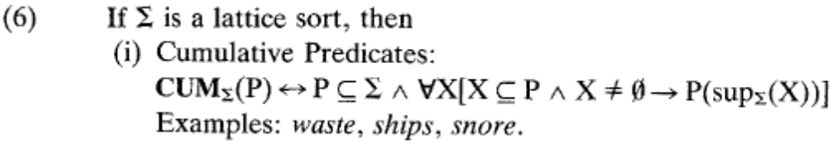
- Using Lattice Sorts we can specify the quantized reference property so that:
  - 4000 ships doesn’t have a proper subpart which is 4000 ships
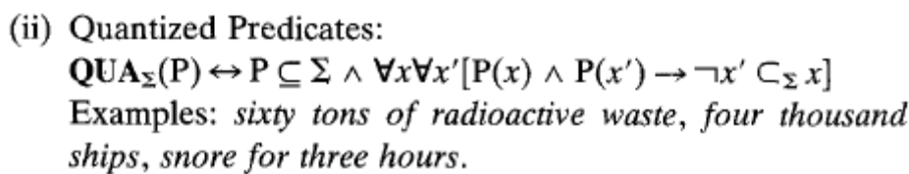
2.2. Measure Functions on Lattices
- Measure functions are functions from concrete entities (ships) to abstract entities (ship passings) such that empirical relations (like 4000) are preserved.
From Landman 1991, a visual of a homomorphism:
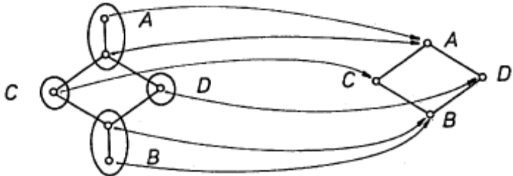
- We are interested in Extensive Measure Functions
  - Concatenation = Numerical addition
  - 10 ships + 20 ships = 30 ships
  - Measure functions whose domain is a subset of the lattice sort, which are positive, which can be extended to parts, and which are additive with respect to the join
- Categorical Grammar Derivation
  - Functions that we’ll need:
    - SEM is 2 place operation of semantic composition
    - SEM (a,b) is defined if b(a) or a(b)
  - Types that we’ll need:
    - N : noun
    - N/N :modifier, takes a N and returns an N
    - Nu : number words
  - Lexicon:
    - Tons is a measure function of QUA_{Σ}, so inserting “tons” into (8) we get:
    - Tons [(N/N)/Nu] λnλPλu[P(u) ʌ ton’(u) =n
  - Derivation:
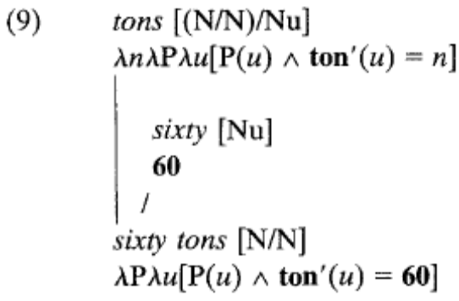
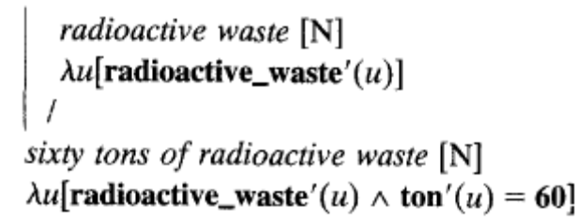
- Proof that (8) a measure function like “tons” is quantized:
x₃
x₂
x₁
x₃
X₂ =n
X₁=n
  - Assume that “tons” is not quantized.
  - x₂ is part of x₁, by distributivity there is another part x_{3,} which is the witness set of x₂ ₍no overlap between x₂ and x₃, and the union of x₂ and x₃ is x₁)
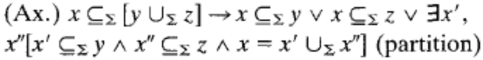
  - If tons of x₁ is 4000, and tons of x₂ is 4000 (by cumulativity) then x₃ should be 0 (4000+?=4000), but by positivity it can’t be.
  - So “tons” cant be cumulative.
  - If its not cumulative, it must be quantized
- Count nouns like “ship” have a measure function built in since they don’t take a measure word.
  - Ships [N/Nu]
  - λnλu[ship’(u)=n]
Krifka assumes that the number morphology (-s) is syntactic agreement.
3. A treatment of object-related and event-related readings
3.1. The Object-Related Reading
- Derivation of the object related reading of “four thousand ships pass through the lock” where the total number of ships is 4000.
  - Relation: Pass-through-the-lock [V/NP]
    - λuλe[pass_through_the_lock’(e,u)]
  - Ø [NP/N] (applies to four thousand ships)
    - λQλRλe∃u[R(e,u) ⋀ Q(u)]
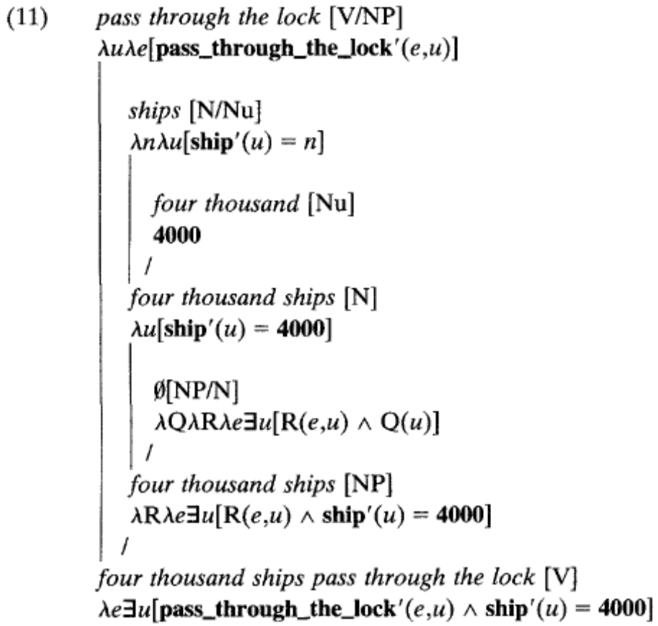
- The result is events of lock traversals by four thousand ships.
- Need to derive the Suficient Condition: that there are 4000 ships, each of which passed through the lock.
  - Solution: assume summativity
    - What does summativity do:
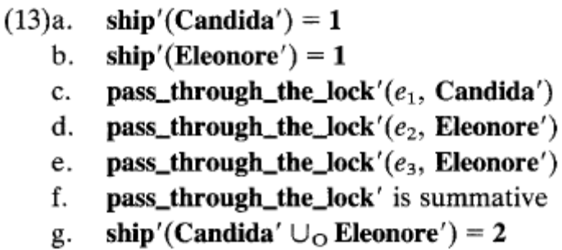
e₃
e₂
e₁
Eleonore
Candida a
Iterative
    - Candida is represented by Candida’
    - Eleonore is represented by Eleanore’
    - Event₁ is a passing through the lock by Candida’
    - Event₂ is a passing through the lock by Eleonore’
    - Event₃ is also a passing through the lock by Eleonore’
    - Pass through the lock is summative so by idempotency (e_{1,} e₂, e₃) is (e_{1,} e₂, e₃) and (Candida’, Eleonore’, Eleonore’) is (Candida’, Eleonore’)
    - Thus ship prime (the extensive measure function) applied to the union of Candida’ and Eleonore’ is 2
- From the sentence radical derived in (11) we tag on the declarative operator which existentially binds the event variable.
  - DECL[S/V]
    - λP∃e[P(e)]
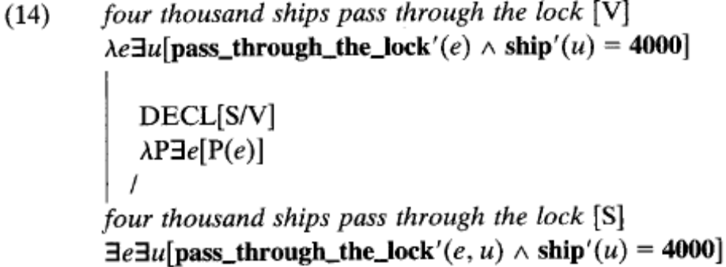
3.2. The Event-Related Reading, First Approach
Simple Semantics - Non-surface-y Syntax
- OEM: To get the event-related reading we need a new measure function with two parts
  - δ A measure relation (like that inherent in ship)
  - α An event relation (pass-through-the-lock)
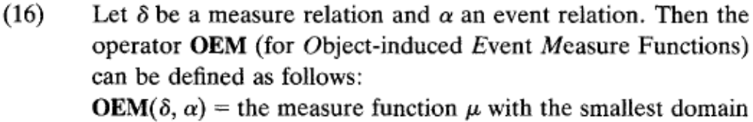
- Standardize μ:
  - If mu is applied to an event e which is non-iterative with respect to the event relation, it gives us the number of ships which passed through the lock in e
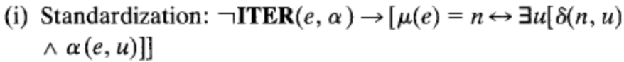
e =n
e’ =n’
e ∪_{Σ} e’ =n+n’

- Generalize μ: (this is what does the work)
  - Use Additivity: if event e has n ships, and e’ has n’ ships, then the join of the events should be n + n’ ships-passings.
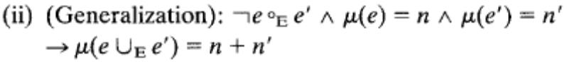
- Iterative Event: an event is iterative if there was one u where R of u applies to more than one part of the event. (ie, u did R more than once)
e
e’’
e’
u
- Derivation of the event-related reading (weird syntax approach)
  - Ø [NP/Nu] (applies to ships)
    - λR’λRλnλe[OEM(R’,R)(e)=n]
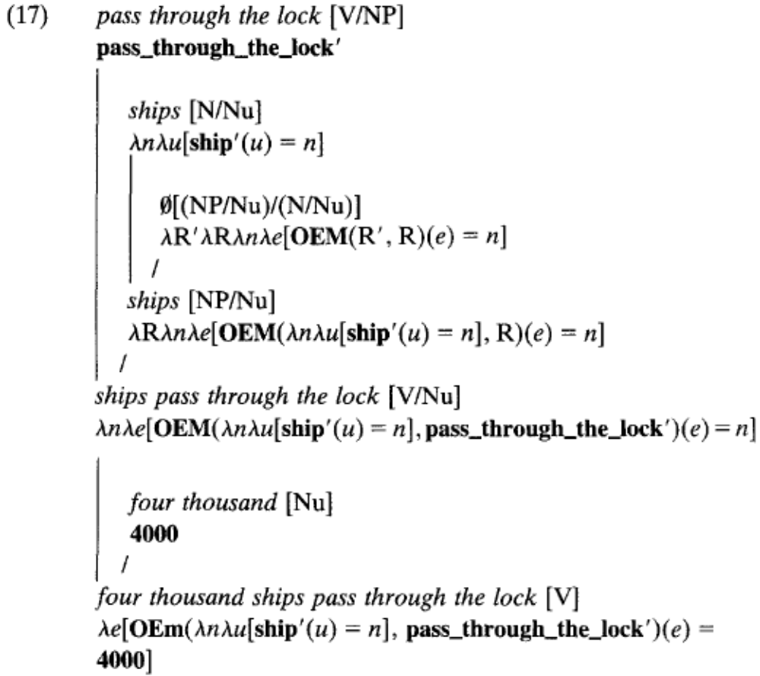
- This derivation can yield both results:
  - Object-Related Reading: If μ is applied to an event e which is non-iterative (unique ships) by standardization it gives us the number of ships which passed through the lock in e.
  - Event-Related Reading: If μ is applied to an event e which is non-iterative (non-unique ships) by additivity μ yields a value for the join of the events e₁, e₂, … e_{m}
  - Note, if e’ is the passing of 2 ships, and e’’ is the passing of 3 ships, additivity will give us 5 ships (or ship-passings?).
- Example: If we take the same 3 events as before, events e₂ + e₃ were done by Eleonore, and e₁ was done by Candida. We partition them in (20) so that the iterativity of Eleonore is broke up:
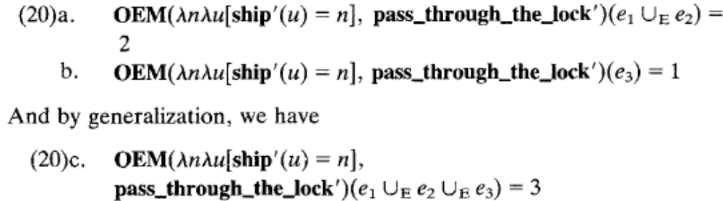
- This first approach gives a strange syntactic tree where “four thousand” doesn’t combine with ships as constituency tests show, but rather the number combines with the sentence radical “ships pass through the lock”.
Four thousand ships pass through the lock
qp
four thousand ships pass through the lock
qp
ships pass through the lock
qp
Ø (OEM determiner) ships
- Problem with Approach 1:
  - Semantics tells us: Sixty [ [tons of radioactive waste] were transported through the lock last year. ]
  - Syntax tells us: [ [Sixty tons of radioactive waste] were transported through the lock last year. ]
3.3. The Event-Related Reading, Second Approach
- One could try to raise the type of the number word so that it takes a count relation (ships) and an event relation (pass through the lock)
- But instead:
  - Have the measure function in the verbal predicate (pass through the lock)
  - The nominal predicate (4000 ships) specifies a value for it
  - The construction of the measure function and the specification of the value is built into the meaning of a special determiner
  - The values/range are quantized predicate extensions (4000 ships) rather than numbers (4000)
- Degree addition: addition of degrees (degrees are quantized predicates): an addition operation on the quantized subsets of the lattice that mirrors addition on numbers (in that it takes two non-overlapping atoms and adds them)
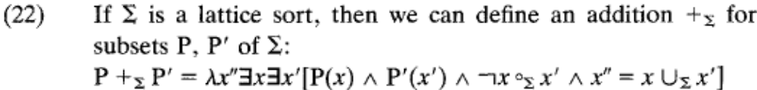
  - In prose: “The 'sum' of the sets P and P' is the set of all elements which consist of two non-overlapping parts which are elements of P and P', respectively.”
x’
x
x’’
P
P’
  - Example of degree +_{o} addition with ship:
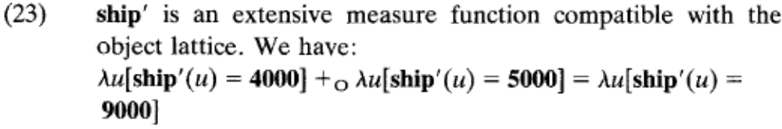
- Property addition: (same degree addition, only in an intentional model) to make sure that there are enough ships in the world, we need to incorporate intensional capabilities, so we will turn these degree predicates in to degree properties.
- Want to claim that the intensions of, say, 9000 ships and 10000 ships is different, even in worlds in which there exist less than nine thousand ships.
- To keep things simple, Krifka remains extensional, but assumes that the model structures are large enough to the degrees needed.
- Now we have to use a Measure Relation instead of a Measure Function as the “value” isn’t uniquely determined
  - As Four thousand ships passed, is the same as four thousand barges passed
- OEMR (Object-induced Event Measure Relation)
  - Σ is a quantized predicate in a lattice sort (like 4000 ships) (in the OEM it used to be δ A measure relation (like that inherent in ship)
  - α An event relation (pass-through-the-lock)

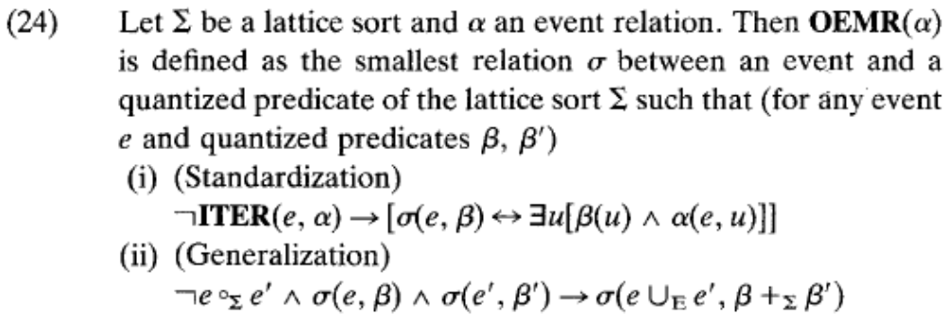
- Derivation of the event-related reading using a OEMRelation:
  - Ø [NP/N] (applies to 4000 ships)
      - λPλRλe[OEMR(R)(e,P)]
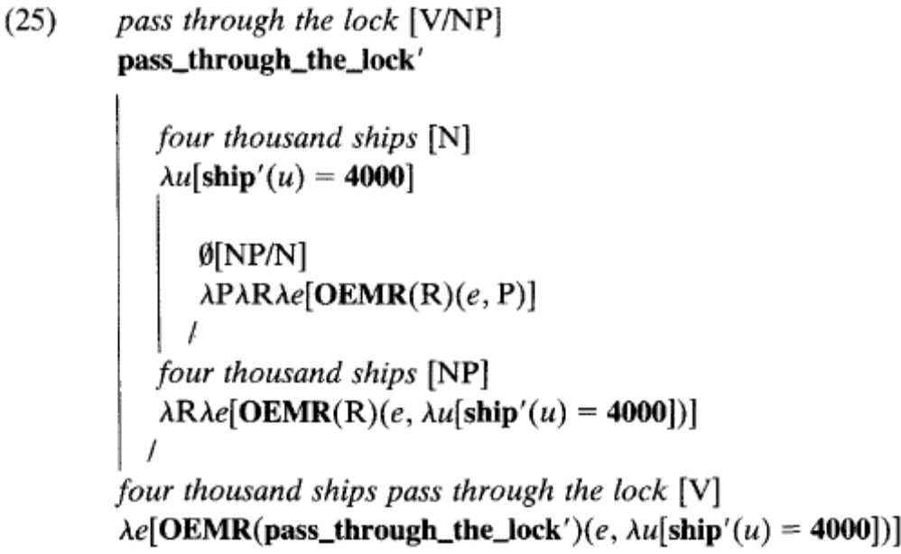
- A comparison of the two OEMs:
First approach (weird syntax): | Second Approach:
Object-induced Event Measure Function | Object-induced Event Measure Relation.
OEMR(δ,α) | OEMR(α)
δ A measure relation (like that inherent in ship) | Σ quantized predicate of a lattice sort (for any event e, quantized predicates β, β’) ?
α An event relation (pass-through-the-lock) | α An event relation (pass-through-the-lock)
Yields: the smallest measure μ | Yields: the smallest relation σ
 | 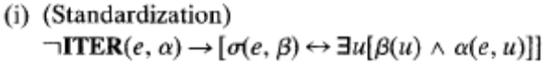
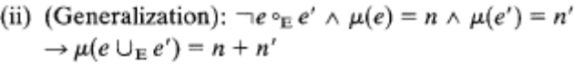 | 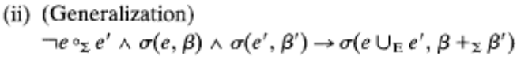
Ø [NP/Nu] (applies to ships)  λR’λRλnλe[OEM(R’,R)(e)=n] | Ø [NP/N] (applies to 4000 ships)  λPλRλe[OEMR(R)(e,P)]
- There is an additional determiner that isn’t present in an Object-Related Reading.
  - It introduces the OEMR, and gives its value as (e,P)
- Example of Mass nouns:
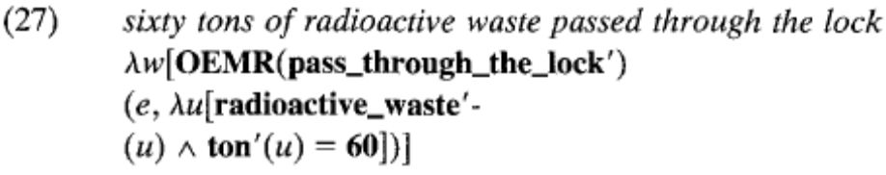
- The Example of Eleonore and Candida: e₁ is a Candida-passing and e₂ ∪_{Σ} e₃ are Eleonore-passings
- Partition the events in to non-iterative parts by separating the Eleonore events, and apply standardization:
- By generalization:
- Adding them up:
- Pragmatic Maximalization: 4000 ships passed through the lock is true in both the object-related and event-related readings, even if 5000 ships passed through the lock, but we conclude pragmatically that only 4000 did by scalar implicature.
4. Further Cases of Event Related Readings
4.1 Coordinated Degrees (degrees are quantized properties)
- Quantized properties like “three thousand freight barges” can be coordinated:
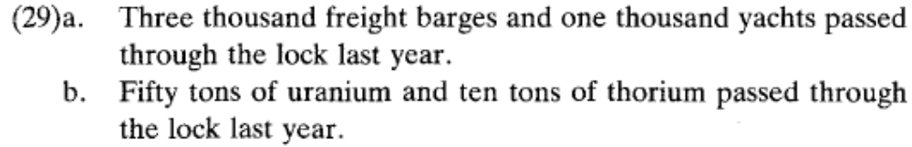
- Under the first approach OEM we could say that these are underlyingly coordinated sentences.
- This can be done by raising the type of the number words, and adding a coordination operation where S and S’ represent variables of type λRλeΦ (Φ is a function, below its …?):
- This is complicated. So:
- Under the second approach OEMR Krifka proposes a conjoined NP instead of sentences, and makes a predicate conjunction in the form of predicate addition from (22).
  - “3000 freight barges and 1000 yachts”
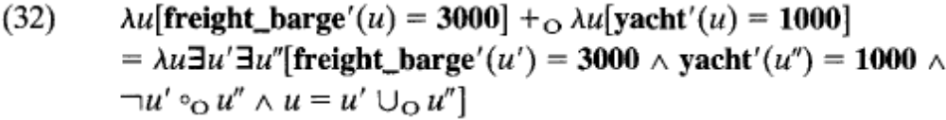
- In the object-related reading the conjoined NP picks out an object which consists of 3000 freight barges and 1000 yachts, and such an object passed through the lock
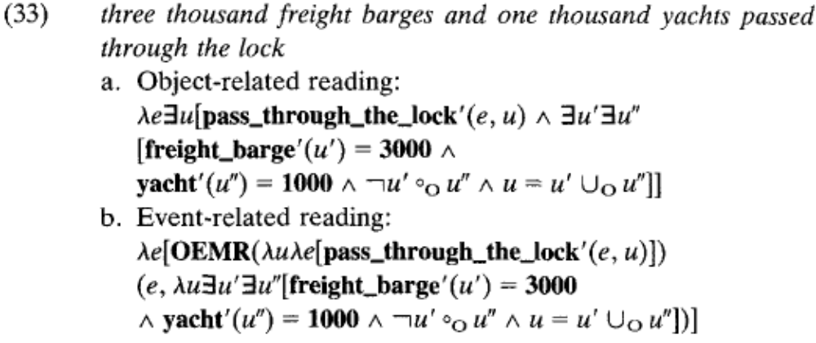
u’’
Yacht
1000
u’
freight
barge
3000
e
Non-Iterative

4.2. Comparison Constructions
- Using Seuren 1973’s comparative semantics:
  - Derivation of COMP and the degree variable d
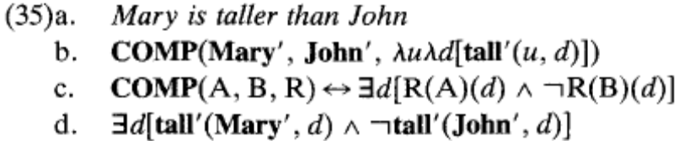

- Applying this COMP to the OEMR:
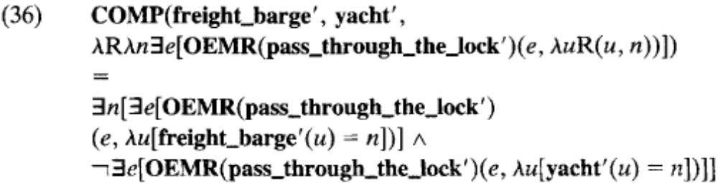
  - In prose: There is a number n such that n freight barges passed through the lock (in the event-related reading), but it is not the case that n yachts passed through the lock (in the event-related reading).
4.3. Quantifiers
- Using Barwise and Cooper’s 1981 Generalized Quantifier theory
    - Object-induced reading: More than half of the ships pass through during the night.
    - Event-induced reading: More than half of the lock transversals happen during the night.
- Define a maximalization operation: max(P) which yields the maximal number n such that P of n is true.
  - R is a variable over count nouns.
- Need quantified nouns to combine with an event relation and yield an event predicate.
  - Maximal Event predicate: MXT, applies to the event which contains every event that occurred during that reference time. (Krifka 1989)
- Derive the event-induced reading with a quantified NP
  - Most [NP/(N/NU)]
  - λR’λRλe[MXT(e) ⋀ max(λn∃u∃e’[R’(u,n) ⋀ R(e’,u) ⋀ e’ ⊆ e]) ÷max(λn∃u[R’(u,n)] > ½
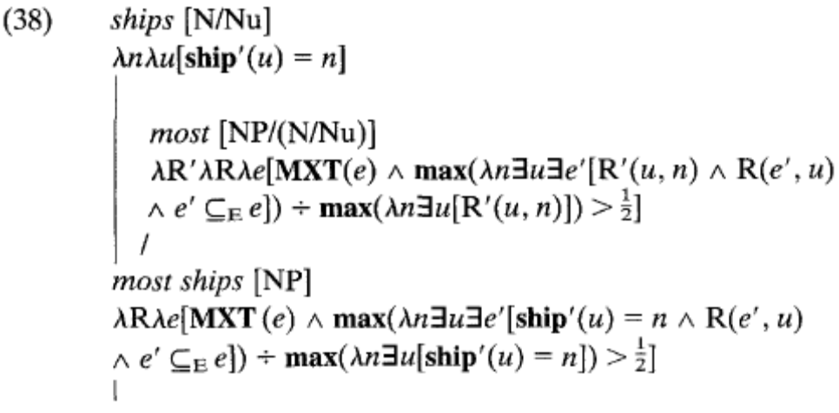
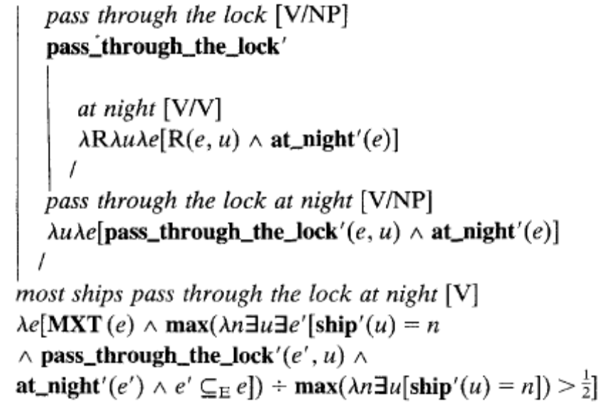
- Apply it to the scenario we have:
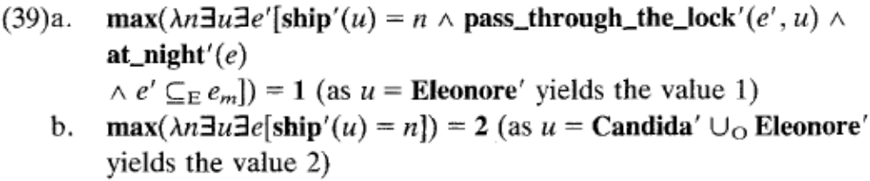
The event related readings in (37) can have different focus assignments and therefore different truth conditions.
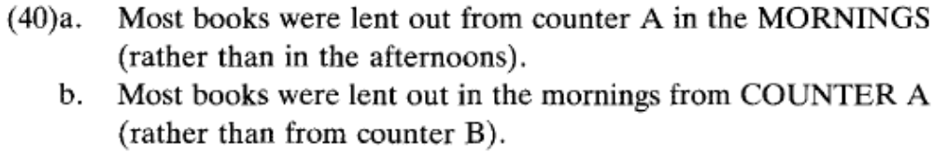
- Two options:
    - structured semantic representations Cresswell and von Stechow (1982), Jacobs (1983)
    - semantic representations with alternatives Rooth (1985)
- Krifka adopts a variant of structured semantic representations (β,α,α),
  - β the structured semantic representation of the background
  - α a structured semantic representation of the focus
  - α a free occurrence of the variable alpha ?
  - Projection operators (BC,FC,VR) gets the value of each of these areas respectively
  - Process of focusation marked by capitalization and indicated in the syntactic representation by brackets indexed with f, it takes a basic semantic representation α and makes the triple.
  - When a focused constituent is composed with a non focused constituent he properties of the new constituent go into the Background.
  - A declarative operator which replaces all free occurences of the focus variable in the background by the focus constituent.
- Derivation using focus and event related reading of (37a):
  - Need an identity function
  - ID(R)= λRλxλy[R(y,x)] if R is type <<e,e,t>,<e,e,t>>
  - Lexicon:
  - Null determiner which applies to “pass through the lock”
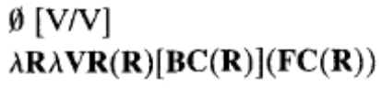
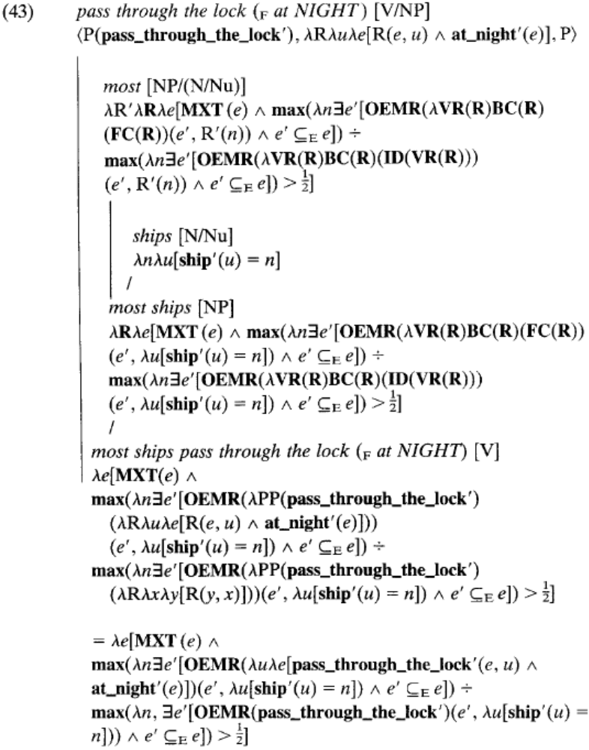
- This predicate applies to maximal events e with the property that the proportion of the maximal number n such that n ships passed through the lock at night (event-related interpretation) in e to the maximal number n such that n ships passed through the lock (also event-related interpretation) in e is greater than n
- “Most ships” is both a nominal and an adverbial quantifier:
  - Nominal: combines with a noun and binds a syntactic argument of the verb (the subject)
  - Adverbial quantifier: based on a relation between classes of events and needs a constituent in focus
- For mass nouns cant just rely on numbers to determine the proportions.
  - This applies to both the object-induced reading and the event-reduced reading.
  - Have to invoke an appropriate dimension (weight or volume) which is a separate problem.

4.4. Problems of Anaphora
- Anaphora can refer to the subject of these sentences, even in the event related readings.
- Krifka proposes that “they” doesn’t refer to the entity in the first sentence, but rather a conventionally related entity, on a parallel with the windshield of a car.
- Notice that the windshield is a full NP, where as they in (46a) is a pronoun.
- Krifka proposes that the concept of ship is introduced in the first sentence, and they refers to concept.
4.5. Phase Nouns
- Phase nouns are what Krifka calls Carlson’s batter and Gupta’s passenger.
  - Non-phase nouns (person in 48b) can have both the object-related reading and the event-related reading, but the phase noun (passenger in 48a) cannot.
  - Krifka assumes that “passenger” does have both readings, but they have the same truth conditions.
    - A passenger is defined for an event, so by either way of counting (object-related or event-related) you get the same number.
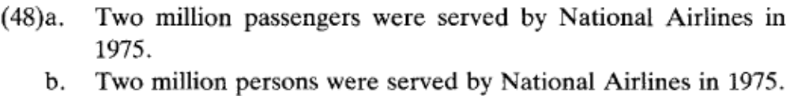
- Phase nouns are kind of like the reverse of the induction of measure functions, we derive a measure function from events to objects instead of objects to events.
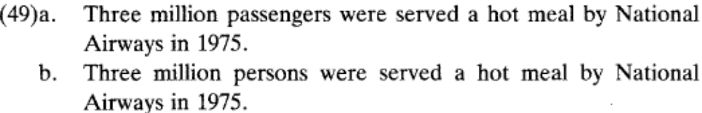
5. Conclusion
- Krifka shows that we can analyze the event-related meanings of (1) using a measure function/relation on events that are induced by a measure function on objects.
- There are other examples of deriving measure from another measure:
  - Containers measure contents
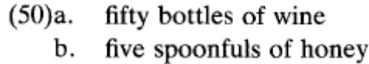
  - Distance measures movement
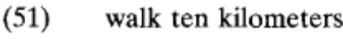
  - Fatalities measures time
- A module of the cognitive system for gradation and measurement (Bierwisch 1987)

Summary:
Object-Related Reading determiner
  - Ø [NP/N] (applies to 4000 ships)
    - λQλRλe∃u[R(e,u) ⋀ Q(u)]
Event-Related Reading Null determiner
  - Ø [NP/N] (applies to 4000 ships)
    - λPλRλe[OEMR(R)(e,P)]

